Riot API Challenge

“URF Quest”
Game Design Document



Team:
Matthew Baker – mrriktor@gmail.com
Vincent Biancardi - Sabin-@live.com
Table Of Contents
Executive Summary –---------------------------------------------------------------------------------------------- 3
High Concept–---------------------------------------------------------------------------------------------------- 3
Locale–------------------------------------------------------------------------------------------------------------- 3
Basic Controls–--------------------------------------------------------------------------------------------------- 3
Game Goal–------------------------------------------------------------------------------------------------------- 3
Target Platform–-------------------------------------------------------------------------------------------------- 3
Game Overview–------------------------------------------------------------------------------------------------- 3
Win/Lose Conditions–------------------------------------------------------------------------------------------- 3
Story –---------------------------------------------------------------------------------------------------------------- 4
Purpose -------------------------------------------------------------------------------------------------------------- 4
User Interaction –--------------------------------------------------------------------------------------------------- 5
Main Menu -------------------------------------------------------------------------------------------------------- 5
High Score Screen –---------------------------------------------------------------------------------------------- 6
How-To/About –-------------------------------------------------------------------------------------------------- 7
Team Selection Screen –----------------------------------------------------------------------------------------- 8
Progression Screen –--------------------------------------------------------------------------------------------- 9
Battle Screen –--------------------------------------------------------------------------------------------------- 10
Player Controls and Indicators -------------------------------------------------------------------------------- 11
Levels –-------------------------------------------------------------------------------------------------------------- 12
Level 1 ------------------------------------------------------------------------------------------------------------ 12
Level 2 ------------------------------------------------------------------------------------------------------------ 13
Level 3 ------------------------------------------------------------------------------------------------------------ 14
Level 4 ------------------------------------------------------------------------------------------------------------ 15
Level 5 ------------------------------------------------------------------------------------------------------------ 16
Level 6 ------------------------------------------------------------------------------------------------------------ 17
Level 7 ------------------------------------------------------------------------------------------------------------ 18
Level 8 ------------------------------------------------------------------------------------------------------------ 19
Level 9 ------------------------------------------------------------------------------------------------------------ 20
Level 10 ----------------------------------------------------------------------------------------------------------- 21
Level 11 ----------------------------------------------------------------------------------------------------------- 23
Future Goals –------------------------------------------------------------------------------------------------------- 24
Special Thanks ----------------------------------------------------------------------------------------------------- 24

Executive Summary

High Concept
By choosing a team from a random group of matches, fight your way through 10 stages of minions and monsters familiar with summoner's rift in order earn the right to fight the final boss... URF the Manatee.

Locale
The game takes place on the Summoner's Rift of League of Legends.

Basic Controls
The player will navigate the game by selecting options and dragging and dropping objects using the mouse.

Game Goal
Defeat all 10 stages by choosing the best team based upon the stats of the players in the randomly retrieved URF matches.

Target Platform
Unity Webplayer and PC, Mac & Linux Standalone ( Future: Mobile )

Game Overview
The player is presented with a list of random matches from URF games. The player will select the match that they feel will be able to progress the farthest based upon the overall attack and health of the team. Once a team is selected the player will enter the rift and battle minions, progressing through the jungle camps, dragon, baron, the NA LCS shoutcasters and finally fighting URF. Battle will be conducted using a turn based system. Initiative will be determined by the base movement speed of the champion, attack and health values will be derived from a calculation of KDA, damage taken and damage dealt to champions. Each player “party member” will be given the option to either attack or taunt any given enemy target. Battle is concluded when a team has lost all of their party members.

Win/Lose Conditions
Winning the game is accomplished by progressing through all ten stages in the end beating the mighty Urf. The player will lose when they have been defeated in three battles.

Story

The day was April 1st, and there was no doubt in anyone's mind that something was fishy on Summoner's Rift. The smell of the ocean permeated through everyone's nostrils, but all that could be seen was the rift. The fishy smell was more than just a notification in the brain that something was off, the pungent aroma sent a surge through every champion increasing their already inhuman fighting abilities. For weeks, a trail of death and destruction like had never been seen before decorated Summoner's Rift. At first it was confusing, but that confusion quickly turned into fun with horror quickly setting in. How long can this craziness go on? It needed to be stopped. The fishy smell that bolstered the champions must be emanating from the long forgotten URF, but this could not be… could it? Warwick slayed the beast many many years ago, perhaps realizing the damage he would cause in time. Somehow he is destroying the rift from the beyond. YOU MUST STOP HIM! The monsters of Summoner's Rift are happy to protect their unseen master, so in order for you to complete your quest you must defeat them and learn where this manatee is hiding. Good luck Summoner!

Purpose

We have noticed that outside of League of Legends itself, there is no way enjoy what the rift has to offer in an entertaining way. We came up with this idea to present an opportunity to give the player a mobile application that they can use League of Legends match history data to have a fun time outside of being on their computer. We believed that this not only drives a player to enjoy the League of Legends brand, but also to play better on the rift because of the ability to use the player's own match data to build a great team to fight their friends with.

User Interaction

Main Menu Screen
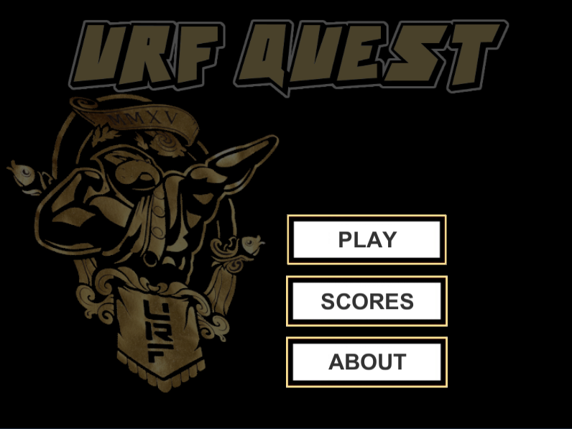

The main menu screen is where the player is put when the application loads. The player is presented with the option to start the game, view high scores or view an about.

High Scores Screen
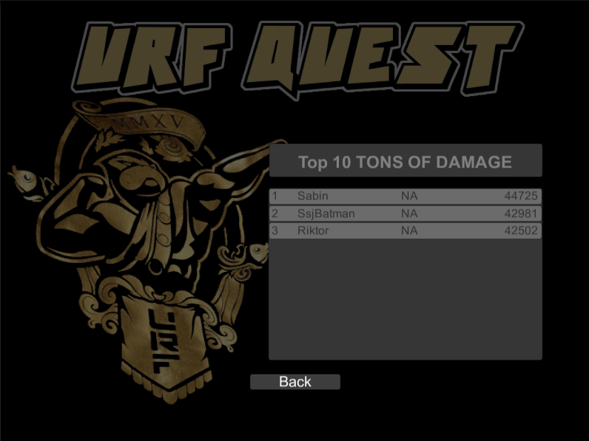
The high scores screen show a list of the top 10 player scores. If the player clicks on the summoner's name, the player is navigated to the selected summoner's profile on LoLKing.net.
How To/About Screen
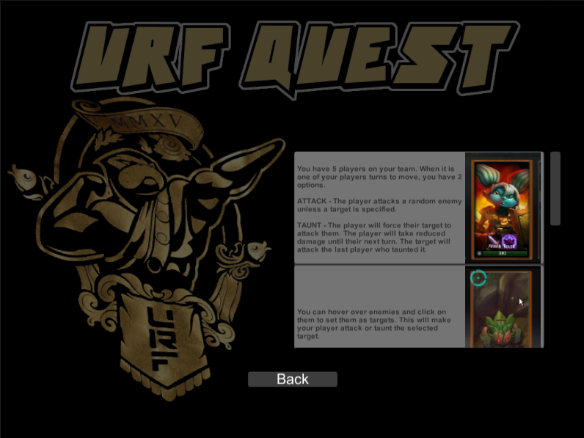
The about screen serves as a place for the user to be given simple instructions on how to play the game. What the Battle System looks like and also credits to the development team and their supporting family members and friends.
Team Selection Screen
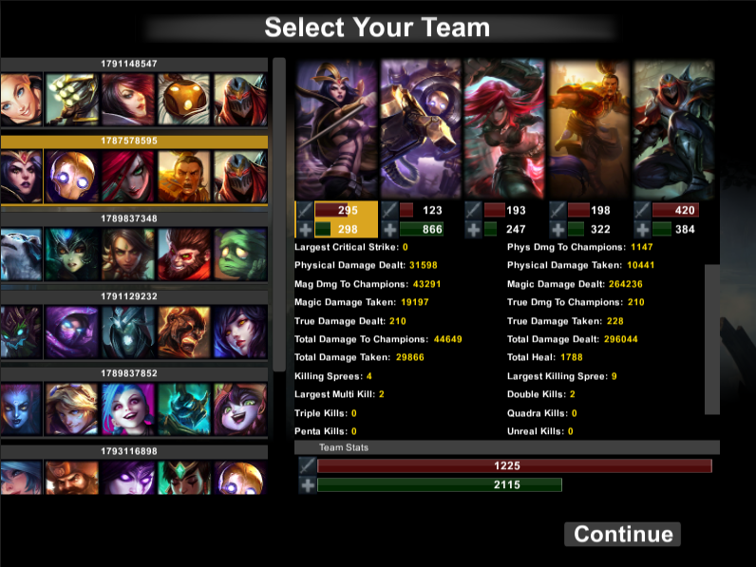
When the player selects the play option, the team selection screen is displayed. This screen is where the player will select from the matches retrieved for them to use. These matches are retrieved from a pool of match Ids pulled from throughout the up-time of the Ultra Rapid Fire game mode. Champion data for those matches are displayed for each summoner for the player to see exactly how the summoner did in that match. Underneath of the champion portrait are the attack and health pool for the corresponding party member. The bar size is an indication of how that champion's attack and health pool match up to the other champion's attack and health pool for all displayed matches. The values are defined using a calculation of KDA, total damage taken and total damage dealt to champions. Team stats values are the total of all champions on this team, the bar size is determined by comparing team total to all other matches displayed.

Progression Screen
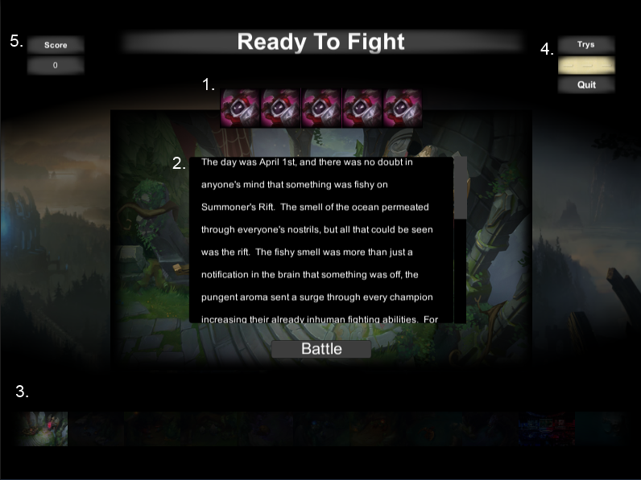

1. Enemy Team Composition – These icons determine the enemy team's composition, the enemies the player will fight this stage.
2. Story – The story of the current stage.
3. Stage progression indicator – this indicator is updated every time the player progress to a new stage.
4. Try Counter – This we display the player's current number of losses.
5. Score – This is the display for the player's current score.
Battle Screen
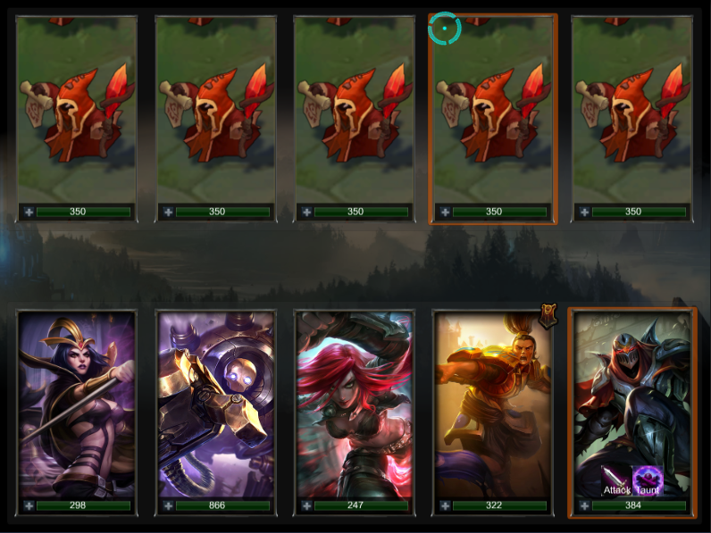
The battle screen is where the primary gameplay takes place. The players team is always on the bottom and the enemy team is always at the top. Battle is conducted on a turn-based format, attack order is determined by the base movement speed of the champions and enemies.

On each of the player's champion's turns, they will be given the opportunity to select a target(if desired) to attack or taunt. Attacking without a target causes the party member to randomly select a living enemy but taunting requires a living target to be selected. Attacking a target will deduct the attacker's attack value from the enemies health pool. Taunting a target will cause that target to attack the taunter on the target's next turn. Also while taunting, the champion will take 25% less damage from all sources. Taunts are overwritten when a champion taunt's an already taunted target but the mitigation remains for all taunters.

On each enemy turn, the enemy will select a random alive target and deduct it's attack damage from the target's health pool.

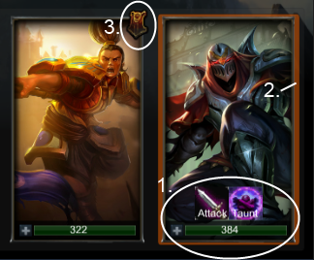
Player Controls and Indicators

- Player HUD – The controls given to the player on a champion's turn.
- Taunt/Attack Panel – The container for the attack/taunt buttons. Only visible when it is the champions turn.
  - Attack Button – Attack the selected target. Attacks a random target if no target is selected.
  - Taunt Button – Taunts the current target. Plays a fail click if no target is selected.
- Health Pool – The total health pool of the champion.
- Turn Indicator – Orange border determines which champion is currently having it's turn.
- Taunt Indicator – This icon is present when the champion is currently in a taunting state.

Enemy Indicators
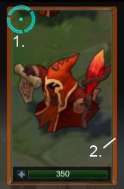
- Target Indicator – This indicator is active when a target is currently selected. It will disappear on death and upon selecting a new target.
- Hover Indicator – This orange border is present when hovering over enemies. It is meant as simple feedback to show that enemies are selectable.

Levels

Name:
Stage 1

Story:
The day was April 1st, and there was no doubt in anyone's mind that something was fishy on Summoner's Rift. The smell of the ocean permeated through everyone's nostrils, but all that could be seen was the rift. The fishy smell was more than just a notification in the brain that something was off, the pungent aroma sent a surge through every champion increasing their already inhuman fighting abilities. For weeks, a trail of death and destruction like had never been seen before decorated Summoner's Rift. At first it was confusing, but that confusion quickly turned into fun with horror quickly setting in. How long can this craziness go on? It needed to be stopped. The fishy smell that bolstered the champions must be emanating from the long forgotten URF, but this could not be… could it? Warwick slayed the beast many many years ago, perhaps realizing the damage he would cause in time. Somehow he is destroying the rift from the beyond. YOU MUST STOP HIM! The monsters of Summoner's Rift are happy to protect their unseen master, so in order for you to complete your quest you must defeat them and learn where this manatee is hiding. Good luck Summoner!

Goal:
To introduce the player to the combat system. This level provides easy enemies for which the player can learn how turn order is handled, how to select targets, and how to attack and taunt enemies.

Attributes:
- Enemy Types
  - Minion
    - Attack Damage: 16
    - Health Pool: 350
    - Movement Speed: 324

Assets:
- Images
  - Icons – The enemies icon displayed on the progression screen.
    - Minion - “Icons/enemy/minion”
  - Portraits – The portrait the enemy has on the battle screen.
    - Minion - “Images/enemy/loading/stage0/minion”
  - Stage Image – The image that is displayed on the progression screen.
    - Resource Path: “Images/stages/stage0”
- Sound Effects
  - Sound Clip Path – The attack sound clip used for when this unit attacks.
    - Minion - “Sound/Attack”

Name:
Stage 2

Story:
Congratulations you defeated the minions and part one of your quest. Your journey has just begun, as minions are only feared by inanimate objects and dull blades of grass. Your next opponent will be a much greater challenge. The minions have divulged to you that the wolves may have more information on the whereabouts of the fish mammal beast.

Goal:
To further introduce the player to the combat system. This level provides easy enemies for which the player can learn how turn order is handled, how to select targets, and how to attack and taunt enemies.

Attributes:
- Enemy Types
  - Greater Murk Wolf
    - Attack Damage: 42
    - Health Pool: 1320
    - Movement Speed: 349
  - Murk Wolf
    - Attack Damage: 16
    - Health Pool: 420
    - Movement Speed: 340

Assets:
- Images
  - Icons – The enemies icon displayed on the progression screen.
    - Greater Murk Wolf - “Icons/enemy/GreaterMurkWolf”
    - Murk Wolf - “Icons/enemy/MurkWolf”
  - Portraits – The portrait the enemy has on the battle screen.
    - Greater Murk Wolf - “Images/enemy/loading/stage1/GreaterMurkWolf”
    - Murk Wolf - “Images/enemy/loading/stage1/MurkWolf”
  - Stage Image – The image that is displayed on the progression screen.
    - Resource Path: “Images/stages/stage1”
- Sound Effects
  - Sound Clip Path – The attack sound clip used for when this unit attacks.
    - Greater Murk Wolf - “Sound/Attack.mp3”
    - Murk Wolf - “Sound/Attack.mp3”

Name:
Stage 3

Story:
The wolves have fallen and the fishy smell grows stronger. Sadly the wolves would not direct you in any particular way, but as you follow your nose you are led to some colorful bird dinosaurs.

Goal:
To further introduce the player to the combat system. This level provides easy enemies for which the player can learn how turn order is handled, how to select targets, and how to attack and taunt enemies.

Attributes:
- Enemy Types
  - Crimson Raptor
    - Attack Damage: 124
    - Health Pool: 1200
    - Movement Speed: 349
  - Raptor
    - Attack Damage: 50
    - Health Pool: 250
    - Movement Speed: 354

Assets:
- Images
  - Icons – The enemies icon displayed on the progression screen.
    - Crimson Raptor - “Icons/enemy/CrimsonRaptor”
    - Raptor - “Icons/enemy/Raptor”
  - Portraits – The portrait the enemy has on the battle screen.
    - Crimson Raptor - “Images/enemy/loading/stage1/CrimsonRaptor”
    - Raptor- “Images/enemy/loading/stage1/Raptor”
  - Stage Image – The image that is displayed on the progression screen.
    - Resource Path: “Images/stages/stage2”
- Sound Effects
  - Sound Clip Path – The attack sound clip used for when this unit attacks.
    - Crimson Raptor - “Sound/Attack.mp3”
    - Raptor - “Sound/Attack.mp3”
Name:
Stage 4

Story:
Finally those dinos have been put down. You are one step closer. Be warned though, it only gets harder from here. You can run away and hide under your seat with a popcorn tub on your head if you would like. However, if you would like to continue, before the raptors died you saw them head toward their rock defenders. Strike Krug down and get closer to winning the day.

Goal:
To further introduce the player to the combat system. This level provides medium difficulty enemies for which the player can learn how turn order is handled, how to select targets, and how to attack and taunt enemies.

Attributes:
- Enemy Types
  - Ancient Krug
    - Attack Damage: 280
    - Health Pool: 1440
    - Movement Speed: 334
  - Krug
    - Attack Damage: 125
    - Health Pool: 540
    - Movement Speed: 344

Assets:
- Images
  - Icons – The enemies icon displayed on the progression screen.
    - Ancient Krug - “Icons/enemy/AncientKrug”
    - Krug - “Icons/enemy/Krug”
  - Portraits – The portrait the enemy has on the battle screen.
    - Ancient Krug - “Images/enemy/loading/stage1/AncientKrug”
    - Krug- “Images/enemy/loading/stage1/Krug”
  - Stage Image – The image that is displayed on the progression screen.
    - Resource Path: “Images/stages/stage3”
- Sound Effects
  - Sound Clip Path – The attack sound clip used for when this unit attacks.
    - Ancient Krug - “Sound/Attack.mp3”
    - Krug - “Sound/Attack.mp3”

Name:
Stage 5

Story:
The giant rocks are now nothing more than gravel thanks to you Summoner. They revealed the next stop of your journey must go through a ginormous slimy frog.

Goal:
To further introduce the player to the combat system. This level provides medium difficulty enemies for which the player can learn how turn order is handled, how to select targets, and how to attack and taunt enemies.

Attributes:
- Enemy Types
  - Gromp
    - Attack Damage: 260
    - Health Pool: 3700
    - Movement Speed: 324

Assets:
- Images
  - Icons – The enemies icon displayed on the progression screen.
    - Gromp - “Icons/enemy/Gromp”
  - Portraits – The portrait the enemy has on the battle screen.
    - Gromp - “Images/enemy/loading/stage1/AncientKrug”
  - Stage Image – The image that is displayed on the progression screen.
    - Resource Path: “Images/stages/stage4”
- Sound Effects
  - Sound Clip Path – The attack sound clip used for when this unit attacks.
    - Gromp - “Sound/Attack.mp3”

Name:
Stage 6

Story:
Gromp went out in an explosion of slime. As you wipe the goo from your brow, you notice a fishy smell looming heavy in the air. The Blue Sentinel is near, and although Gromp was useless, perhaps this blue guardian of the forest has more information that will help you on your quest. Obtaining that information may not be so easy.

Goal:
To test the player's ability to effectively use the combat system. This level provides harder difficulty enemies to test the players ability to effectively juggle aggro from the enemy.

Attributes:
- Enemy Types
  - Blue Sentinel
    - Attack Damage: 256
    - Health Pool: 3000
    - Movement Speed: 334
  - Blue Sentry
    - Attack Damage: 120
    - Health Pool: 600
    - Movement Speed: 324

Assets:
- Images
  - Icons – The enemies icon displayed on the progression screen.
    - Blue Sentinel - “Icons/enemy/BlueSentinel”
    - Blue Sentry - “Icons/enemy/BlueSentry”
  - Portraits – The portrait the enemy has on the battle screen.
    - Blue Sentinel - “Images/enemy/loading/stage1/BlueSentinel”
    - Blue Sentry- “Images/enemy/loading/stage1/BlueSentry”
  - Stage Image – The image that is displayed on the progression screen.
    - Resource Path: “Images/stages/stage5”
- Sound Effects
  - Sound Clip Path – The attack sound clip used for when this unit attacks.
    - Blue Sentinel - “Sound/Attack.mp3”
    - Blue Sentry - “Sound/Attack.mp3”

Name:
Stage 7

Story:
Good job Summoner! The rock guardian has given you much information that will be helpful in your quest. He has confirmed that it is none other than Urf the Manatee behind all this destruction. Before you landed the final blow he directed you toward the mighty Brambleback.

Goal:
To test the player's ability to effectively use the combat system. This level provides harder difficulty enemies to test the players ability to effectively juggle aggro from the enemy.

Attributes:
- Enemy Types
  - Red Brambleback
    - Attack Damage: 323
    - Health Pool: 2000
    - Movement Speed: 334
  - Cinderling
    - Attack Damage: 175
    - Health Pool: 400
    - Movement Speed: 339

Assets:
- Images
  - Icons – The enemies icon displayed on the progression screen.
    - Red Brambleback - “Icons/enemy/RedBrambleback”
    - Cinderling - “Icons/enemy/Cinderling”
  - Portraits – The portrait the enemy has on the battle screen.
    - Red Brambleback - “Images/enemy/loading/stage1/Red Brambleback”
    - Cinderling - “Images/enemy/loading/stage1/Cinderling”
  - Stage Image – The image that is displayed on the progression screen.
    - Resource Path: “Images/stages/stage6”
- Sound Effects
  - Sound Clip Path – The attack sound clip used for when this unit attacks.
    - Red Brambleback - “Sound/Attack.mp3”
    - Cinderling - “Sound/Attack.mp3”

Name:
Stage 8

Story:
You have great strength Summoner, just like a pop artist surfing through the desert. The mighty Brambleback would only give this riddle before his death. "The path to Urf is through the dragon." Whatever could that mean?

Goal:
To test the player's ability to effectively use the combat system. This level provides harder difficulty enemies to test the players ability to effectively juggle aggro from the enemy.

Attributes:
- Enemy Types
  - Dragon
    - Attack Damage: 325
    - Health Pool: 4940
    - Movement Speed: 334

Assets:
- Images
  - Icons – The enemies icon displayed on the progression screen.
    - Dragon - “Icons/enemy/Dragon”
  - Portraits – The portrait the enemy has on the battle screen.
    - Dragon - “Images/enemy/loading/stage1/Dragon”
  - Stage Image – The image that is displayed on the progression screen.
    - Resource Path: “Images/stages/stage7”
- Sound Effects
  - Sound Clip Path – The attack sound clip used for when this unit attacks.
    - Dragon - “Sound/Attack.mp3”

Name:
Stage 9

Story:
Amazing Summoner! The dragon has been defeated, but no new information was gained. By process of elimination, and the fact you have killed everything else on the rift, what do you say we head to Baron, the source of so many throws.

Goal:
To test the player's ability to effectively use the combat system. This level provides harder difficulty enemies to test the players ability to effectively juggle aggro from the enemy.

Attributes:
- Enemy Types
  - Baron
    - Attack Damage: 400
    - Health Pool: 8800
    - Movement Speed: 324

Assets:
- Images
  - Icons – The enemies icon displayed on the progression screen.
    - Baron - “Icons/enemy/Baron”
  - Portraits – The portrait the enemy has on the battle screen.
    - Baron - “Images/enemy/loading/stage1/Baron”
  - Stage Image – The image that is displayed on the progression screen.
    - Resource Path: “Images/stages/stage8”
- Sound Effects
  - Sound Clip Path – The attack sound clip used for when this unit attacks.
    - Baron - “Sound/Attack.mp3”

Name:
Stage 10

Story:
You defeated Baron! Sorry but our Urf is in another castle. The only thing visible around you are the never seen before Urf Guardians. As they move out from the fog of war, terror strikes your heart for these… things… are the most hideous, frightening, creepy, bloodcurdling, chilling monsters you have ever laid eyes on!

Goal:
The purpose of this stage is to test the player's priorities. Simply attacking a target may not be the best strategy in this situation as some of the caster's can kill weaker member of the player's team. Taunting will greatly help the user in pulling attacks from their low health damage dealers but they must beware the tons of damage.

Attributes:
- Enemy Types
  - Rivington
    - Attack Damage: 85
    - Health Pool: 1750
    - Movement Speed: 344
  - Jatt
    - Attack Damage: 50
    - Health Pool: 2500
    - Movement Speed: 329
  - Phreak
    - Attack Damage: 9001
    - Health Pool: 900
    - Movement Speed: 329
  - Kobe
    - Attack Damage: 212
    - Health Pool: 875
    - Movement Speed: 339
  - Dash
    - Attack Damage: 136
    - Health Pool: 1250
    - Movement Speed: 400

Assets:
- Images
  - Icons – The enemies icon displayed on the progression screen.
    - Rivington - “Icons/enemy/Rivington”
    - Jatt - “Icons/enemy/Jatt”
    - Phreak - “Icons/enemy/Phreak”
    - Kobe - “Icons/enemy/Kobe”
    - Dash - “Icons/enemy/Dash”
  - Portraits – The portrait the enemy has on the battle screen.
    - Rivington - “Images/enemy/loading/stage1/Rivington”
    - Jatt - “Images/enemy/loading/stage1/Jatt”
    - Phreak - “Images/enemy/loading/stage1/Phreak”
    - Kobe - “Images/enemy/loading/stage1/Kobe”
    - Dash - “Images/enemy/loading/stage1/Dash”
  - Stage Image – The image that is displayed on the progression screen.
    - Resource Path: “Images/stages/stage9”
- Sound Effects
  - Sound Clip Path – The attack sound clip used for when this unit attacks.
    - Rivington - “Sound/Rivington.mp3”
    - Jatt - “Sound/Jatt.mp3”
    - Phreak - “Sound/Phreak.mp3”
    - Kobe - “Sound/Kobe.mp3”
    - Dash - “Sound/Dash.mp3”
Name:
Stage 11 – Final Stage

Story:
You have emerged Victorious! With no more monsters protecting him, a wild Urf has appeared!

Goal:
To test the player's ability to judge their own team and adapt to a situation. Urf is strong enough to one shot every target he hits, therefore the player must first learn this, and then make a decision whether they are capable of winning a DPS race, taking the chance on Urf randomly targeting their strongest player or taunting with your meat shields.

Attributes:
- Enemy Types
  - Urf
    - Attack Damage: 99999
    - Health Pool: 5000
    - Movement Speed: 1

Assets:
- Images
  - Icons – The enemies icon displayed on the progression screen.
    - Urf - “Icons/enemy/Urf”
  - Portraits – The portrait the enemy has on the battle screen.
    - Urf - “Images/enemy/loading/stage1/Urf”
  - Stage Image – The image that is displayed on the progression screen.
    - Resource Path: “Images/stages/stage2”
- Sound Effects
  - Sound Clip Path – The attack sound clip used for when this unit attacks.
    - Urf - “Sound/Urf.mp3”

Future Goals

- Custom Teams – We wish to integrate summoner specific champion performance on our next iteration. Instead of merely using a single match an all of it's participants, we want the player to use their own champion performances to populate a custom team to use in our game.
- Multiplayer – Our team desires to bring other into the experience with you, by giving them the opportunity to play against their friends teams in a multiplayer match-making system.
- Larger Story World – We want to expand the “story” of our game. We have thought of taking the current lore and using that in way to explore new worlds that the user is only given a glimpse of on the rift.
- Integration of Magic and Physical Damage and Defenses – We want to expand our damage pool, not just calculating it off of total damage dealt but split it between magic and physical to better support an item system. This is also true with health pool/defense.
- Integration of Items – We want to integrate an item equipment system. This would purchased with gold that is earned in game by traversing the larger story world mentioned above. These would empower your champions and amplify their damage based upon the item type.
- Handheld Device Platform – Our vision for this product is to be something that drives people to play League of Legends better and more often. If given the ability to use good performances from the past, we feel that summoners will try harder to play better on the rift.

Special Thanks

Riktor would like to thank: His wife Casi, for her love, support, and encouragement through the long nights druing this project. His friends on the Rift, mall0w, kefkuh and SSJBatman for supporting our vision and making us excited to see people enjoy playing our game, you guys rock! Riot for creating such a great game in League of Legends and in turn giving me the opportunity to create something fun and entertaining through this challenge!

Sabin would like to thank:

